Appendix 1: Validations since March.2017

|  |  |  |  |  |
| --- | --- | --- | --- | --- |
| **Error Number** | **Error Message** | **Reject Record** | **Description** | **Remediation** |
| 382 | If the Clinical Trial Enrolment Flag is Yes, a Clinical Trial Number must be provided. | Y | If (Clinical_trial_enrolment_flag is yes and the Clinical_trial_number field is missing), reject the record and issue the error message | Provide a clinical trial number |
| 498 | Warning: scans are only reimbursed for Clinical Trial patients. | N | If Facility_Managing_Patient is null and Clinical_Trial_Enrollment_Flag is No and Nuclear_Medicine_Scan_Date is not null, accept the record and issue the warning message. | Scans are only reimbursed for Clinical Trial patients |
| 501 | Error: Apparent duplicate records | Y | If record is for a scan (NUCLR_MED_SCAN_DATE is not null), reject submission with error if there are records where the following fields are the same: HEALTH_CARD_NUMBER, SUBMISSION_ORG_KEY, NUCLR_MED_SCAN_DATE, NUCLR_MED_SCAN_TYPE_KEY | Remove duplicate records |
| 501 | Error: Apparent duplicate records | Y | If record is for a treatment (RADIONUCLID_THERAPY_DATE is not null), reject submission with error if there are records where the following fields are the same: HEALTH_CARD_NUMBER, SUBMISSION_ORG_KEY, RADIONUCLIDE_THERAPY_DATE, RADIO_ISOTOPE | Remove duplicate records |
| 501 | Error: Apparent duplicate records | Y | If record is for both a scan and treatment, reject submission with if there are records where the following fields are the same: HEALTH_CARD_NUMBER, SUBMISSION_ORG_KEY, NUCLR_MED_SCAN_DATE, NUCLR_MED_SCAN_TYPE_KEY OR HEALTH_CARD_NUMBER, SUBMISSION_ORG_KEY, RADIONUCLIDE_THERAPY_DATE, RADIO_ISOTOPE | Remove duplicate records |
| 629 | Facility Managing Patient is incorrect. Please refer to the Facility Number List | Y | If Facility_Managing_Patient is not null and Facility_Managing_Patient is not in the pre-defined list of values, reject the record and issue error message | Select a valid facility_managing_patinet |
| 632 | "When radio isotope is entered, pharmaceutical dose is mandatory" | Y | If radio_isotope is not null and pharmaceutical_dose is null, reject record and display error msg. | Put in a pharmaceutical dose |
| 633 | "When radio nuclide therapy date is entered, radio isotope is mandatory" | Y | If radio_nuclide_therapy_date is not null and radio_isotope is null, reject record and display error msg. | Put in a radio_isotope |
| 634 | "When radio isotope is entered, dose unit is mandatory" | Y | If radio_isotope is not null and dose_unit is null, reject record and display error msg. | Put in a dose unit |
| 635 | "When radio isotope is entered, radio nuclide therapy date is mandatory" | Y | If radio_isotope is not null and radio_nuclide_therapy_date is null, reject record and display error msg. | Put in a radio_nuclide_therapy_date |
| 636 | Facility_Managing_Patient must have a value if Clinical trial number is NCT02743741 and nuclear medicine scan date is entered | Y | If (Nuclear Medicine Scan Date is provided and Clinical Trial Number is NCT02743741 and Facility Managing Patient is missing), reject the record and issue the error message. | Select facility_managing_patient |
| 637 | If a clinical trial number is provided, the Clinical Trial Enrolment Flag must be Yes. | Y | If (Clinical_Trial_Number is a valid clinical trial value and the Clinical Trial Enrolment flag is No), reject the record and issue the error message. | Change clinical trial enrolment to yes OR remove clinical_trial_number |
| 638 | Invalid clinical trial number - consult lookup table in template | Y | If an entry outside of the allowed trial numbers is made, display error message | Select a valid clinical trial number |
| 639 | The field Clinical_trial_enrolment_flag is mandatory | Y | The field Clinical_trial_enrolment_flag is mandatory (always). | Fill in the clinical_trial_enrolment_flag column |
| 670 | Pharmaceutical dose must be a positive number | Y | IF RADIOISOTOPE_DOSE is not null AND RADIOISOTOPE_DOSE < or = 0  THEN RAISE New Error 670 | Input a positive pharmaceutical dose |

# Appendix 2: Facility Numbers[1]

| **#** | **Program Title** | **Submitting Hospital** | **Facility Number** |
| --- | --- | --- | --- |
| 4 | Neuroendocrine | London Health Sciences | 936 |
| Hamilton Health Sciences Corporation | 942 |
| University Health Network | 947 |
| Sunnybrook Health Sciences Centre | 953 |

# Appendix 3: Valid 2-digits Postal Codes[2]

(Source: Cancer Care Ontario's Data Book - 2012-2013, Appendix B - Province and State codes, at link https://www.cancercare.on.ca/ext/databook/db1213/databook.htm).

The table below provides list of valid 2 digit postal codes for province and State codes.

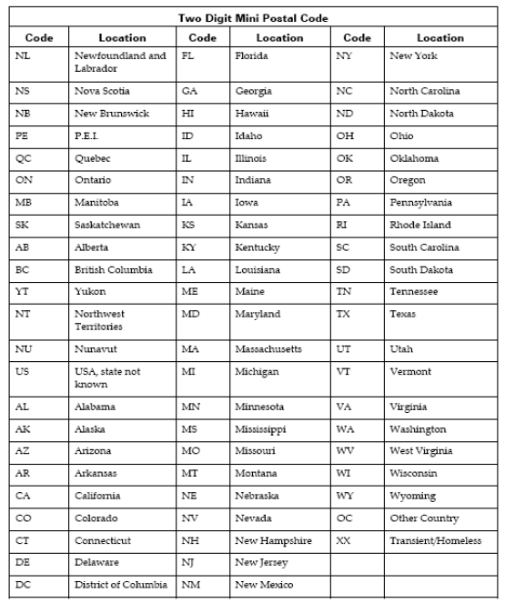

# Appendix 4: Morphology Codes[3]

This is a complete listing of valid Morphology codes and includes the new Haematopoietic codes effective January 2010.

Citation for new classification:

WHO Classification of Tumours of Haematopoietic and Lymphoid Tissues, 4th ed., edited by S. H. Swerdlow, et al., International Agency for Research on Cancer, Lyon, 2008. ISBN 978-92-832-2431-0

(For details, please refer Cancer Care Ontario's Data Book - 2012-2013, Appendix 1.36 - Morphology Codes, at link https://www.cancercare.on.ca/ext/databook/db1213/databook.htm)

# Appendix 5: ICDO-3 Topography with Laterality[4]

This is a table of topography codes where laterality is applied as stipulated in the FORDS manual.

(For details, please refer Cancer Care Ontario's Data Book - 2012-2013, Appendix 1.3 ICDO-3 TOPOGRAPHY with Laterality, at link https://www.cancercare.on.ca/ext/databook/db1213/databook.htm)

# Appendix 6: Pharmaceutical dose unit[5]

This table provides info for Radio pharmaceutical dose unit

| **Unit Code** | **Description** |
| --- | --- |
| cap | capsule |
| MBq | megabecquerels |
| mcg | microgram |
| mEq | milliequivalent |
| MU | million units |
| tab | tablet |
| unit | unit |
| mg | milligram |
| mL | milliliter |
| drop | drop |
| pfu | plaque forming unit |
| cm | centimeter |
| g | gram |
| loz | lozenge |
| mmol | millimoles |
| part | particle |
| ptch | patch |
| pkt | packet |
| pop | popsicle |
| puff | puff |
| supp | suppository |
| mCi | millicurie |

# Appendix 7: Clinical Trial Numbers

|  |
| --- |
| 172567 |
| NCT02743741 |

# Appendix 8: Facility Managing Patient

|  |  |
| --- | --- |
| **Facility Number** | **Facility Name** |
| 936 | London Health Sciences |
| 942 | Hamilton Health Sciences Corporation |
| 947 | University Health Network |
| 953 | Sunnybrook Health Sciences Centre |

1. Corresponds to appendix 3 on ALR
2. Corresponds to appendix 11 on ALR
3. Corresponds to appendix 20 on ALR
4. Corresponds to appendix 21 on ALR
5. Corresponds to appendix 22 on ALR